Great Expectations《远大前程》赏析
——高二英语尹洪芝
本学期所学教材选修七中涉及了狄更斯的作品，鉴于狄更斯在英国文学史中的重要地位，我们进一步学习狄更斯的作品，深入对英国文学、文化的认识，提升英语语言素养。
本节课我们以《远大前程》为中心，了解狄更斯及其所处的维多利亚时代和批判现实主义文学，分析小说情节、人物特点和主题，深入对狄更斯写作风格的理解。
1.The author（作者）：Charles Dickens 查尔斯·狄更斯(1812—1870)
Full Name: Charles John Huffam Dickens (early alias: Boz)
Place of Birth: No. 1 Mile End Terrace, Landport, Portsmouth England
Parents: Father-John Dickens (1785-1851); Mother-Elizabeth Dickens (1789-1863)
Life experiences（人生经历）：
Charles Dickens was born on February 7, 1812, and spent the first nine years of his life living in the coastal regions of Kent, a county in southeast England. Dickens’ s father, John, was a kind and likeable man, but he was incompetent with money and piled up tremendous debts throughout his life.
When Dickens was nine,his family moved to London. When he was twelve, his father was arrested and taken to debtors’ prison. Dickens’ s mother moved his seven brothers and sisters into prison with their father, but she arranged for the young Charles to live alone outside the prison.
Outside, he worked with other children pasting labels on bottles in a blacking warehouse. Dickens found the three months he spent apart from his family highly traumatic. Not only was the job itself miserable, but he considered himself too good for it, earning the contempt of the other children.
After his father was released from prison, Dickens returned to school. He eventually became a law clerk, then a court reporter, and finally a novelist. His first novel , The Pickwick Papers, (《匹克威克外传》) became a huge popular success when Dickens was only twenty—five.
He published extensively and was considered a literary celebrity until his death in 1870. He is buried in the Poet’s Corner in Westminster Abbey （威斯敏斯特教堂）in London. The words of his grave read as follows: “He was a sympathiser to the poor, the suffering, and the oppressed; and by his death one of England’s greatest writers is lost to the world.”（他是贫穷、受苦与被压迫人民的同情者；他的去世令世界失去了一位伟大的英国作家。）
He created some of the world’s most memorable fictional characters and he is one of the greatest critical realists in the Victorian Age. He is the main representative of English critical realism in the 19th century.
Features of writing(写作特点)：
As the greatest critical realist writer of the Victorian Age, Dickens has a serious intention to expose and criticize all the poverty, injustice, hypocrisy and corruptness he sees all around him. On the one hand, he hates all these evils. On the other hand, he can supply no fundamental solution to these social problems, because he was only a bourgeois writer. It seems that the best he can do is to try to retain optimism, as is shown in his early works, or to express a helpless indignant protest, as is shown in his later novels. At the same time he hopes to call people’s attention to the existing social problems and thus bring about some reform.
Works(主要作品)：
The Pickwick Papers(1836)---《匹克威克外传》
Oliver Twist(1837-1839)---《雾都孤儿》
Dombey and Son (1846-1848）---《董贝父子》
David Copperfield(1849-1850)---《大卫·科波菲尔》
Bleak House (1852-1853)---《荒凉山庄 》
Little Dorrit( 1855-1857 ）---《小杜丽》
A Tale of Two Cities(1859)---《双城记》
Great Expectations(1861)---《远大前程》
Our Mutual Friend(1864-1865) ---《我们共同的朋友 》
Edwin Drood(1870) ---《埃德温·德鲁德》
Critical Realism
A new literary trend, critical realism, appeared in Victorian Age(1837-1901) because of tense class struggle between the bourgeois(中产阶级) and the workers. Great writers described the chief traits of the English society and criticized the capitalist system (资本主义体系)from a democratic viewpoint. Marx and Engles called them critical realists.
Representatives & masterpieces:
Charles Dickens; William Makepeace Thackeray(萨克雷):Vanity Fair《名利场》
Charlotte Bronte :Jane Eyre《简爱》; Emily Bronte : Wuthering Heights《呼啸山庄》
2.Great Expectations《远大前程》
Setting（背景）
TIME: early 19th century (early 1800s)
PLACE: Dickens set the first section of GE in marshy country called the Medway, where the Thames River begins to mix with seawater. He knew this area well, as he spent the happiest years of his childhood in the Medway town of Chatham. The churchyard with children’s graves is in
Cooling, and Pip’s village is probably Cliffe. In 1856, Dickens purchased Gad’s Hill Place, a large house near Rochester (the town where Miss Havisham and Pumblechook live).
Plot（情节）：见课本37页与阅读材料
Characters（角色）
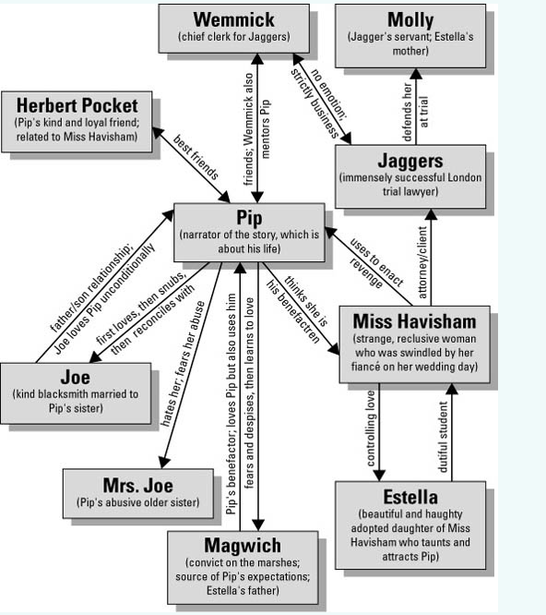
Pip：hero of the novel; immature, romantic idealism and innately good conscience
Mrs. Joe Gargery: the sister of Pip;Imperious(专横的),mean,aggressive
Joe Gargery: Pip’s brother-in-law;quiet,honest,simple, warm-hearted, kind, generous, considerate
Herbert Pocket: innocent; kind; loyal; gentle
Magwitch: a fearsome criminal , Pip’s secret benefactor,grateful, kind and generous to Pip
Miss Havisham:wealthy, eccentric（怪异的）； manic （疯狂的）and often seems insane; an example of single-minded vengeance（报仇） pursued destructively
Estella:young ,beautiful ,cruel ,cold ,uninterested in Pip
Biddy: simple, kindhearted girl, represents the opposite of Estella; plain, kind, moral, and of Pip’s own social class.
Themes（主题）：
Ambition and Self-Improvement：
Affection, loyalty, and conscience are more important than social advancement, wealth, and class.Dickens establishes the theme and shows Pip learning this lesson, largely by exploring ideas of ambition and self-improvement—ideas that quickly become both the thematic center of the novel and the psychological mechanism that encourages much of Pip’s development.
Social Class
Throughout Great Expectations, Dickens explores the class system of Victorian England, ranging from the most wretched（不幸的）criminals (Magwitch) to the poor peasants of the marsh（沼泽） country (Joe and Biddy) to the middle class (Pumblechook) to the very rich (Miss Havisham).Perhaps the most important thing to remember about the novel's treatment of social class is that the class system it portrays is based on the post-Industrial Revolution model of Victorian England. Dickens generally ignores the nobility(贵族阶层）in favor of characters whose fortunes have been earned through commerce（商业）.Social class (and the treatment between and among members) is central to the novel’s plot and to the ultimate moral theme of the book.
Friendship & Loyalty
Which characters exhibit one or both of these?
How? Why? Under what circumstances?
What is the impact of the exhibition of friendship and / or loyalty?
Summary（结语）
本节课我们简要学习了狄更斯的作品《远大前程》，了解了狄更斯的写作风格和批判现实主义。课下同学们可以通过观看电影、阅读原著加强对狄更斯及其所处的时代的理解，进一步认识英国文学史。

